

Technical Documentation
of
Storelocator

Document ID:5465 and 5468
Document Version:1.0
Authors:Lavanya M and Vinayaka B S

Technical Documentation

1. Overall Description
This document contains all the details that we successfully finished. The storelocator typically requires the database which contains store name, address, city, state and pincode which may be relevant to the user. Here, we are going over how to create a grid and from, create an google map, create the dropdown menu with selected cities, displayed store id, store name, address, city, state, pincode, moile number, map, latitude and longitude.
2. Tecnical Requirements
2.1 GRID and FORM
Step 1: Creating the Module: In the magento root directory app/code, create the folder to build the extension in a given structure which is defined as VendorName_MyModule, in this project the vendor name is ‘Embitel’ and module name is ‘Storelocator’.
app/code/Embitel/Storelocator/etc/module.xml
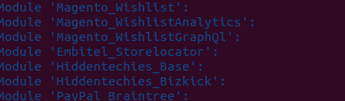

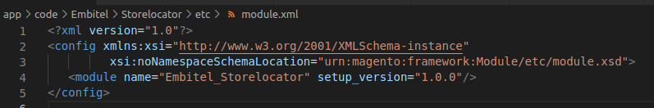

Step 2: Create the acl.xml: Magento 2 admin acl use an authentication system and a robust system for create Access Control List Rules (ACL) which allows a store owner to create fine grained roles for each and every user in their system.

Technical Documentation

app/code/Embitel/Storelocator/etc/acl.xml

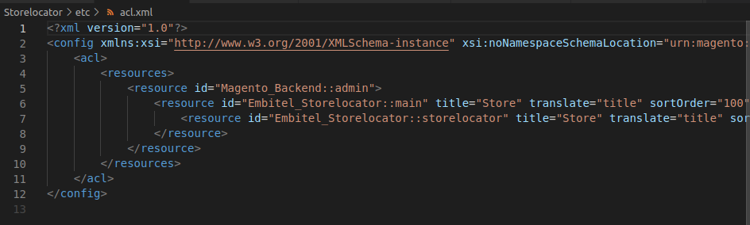
Step 3: Create the db_schema.xml: This file is used to create the new tables or maintain the tables which avoids the unneccesary version checking for creating new columns or delete columns and also for backward compactibility with php script.

app/code/Embitel/Storelocator/etc/db_schema.xml

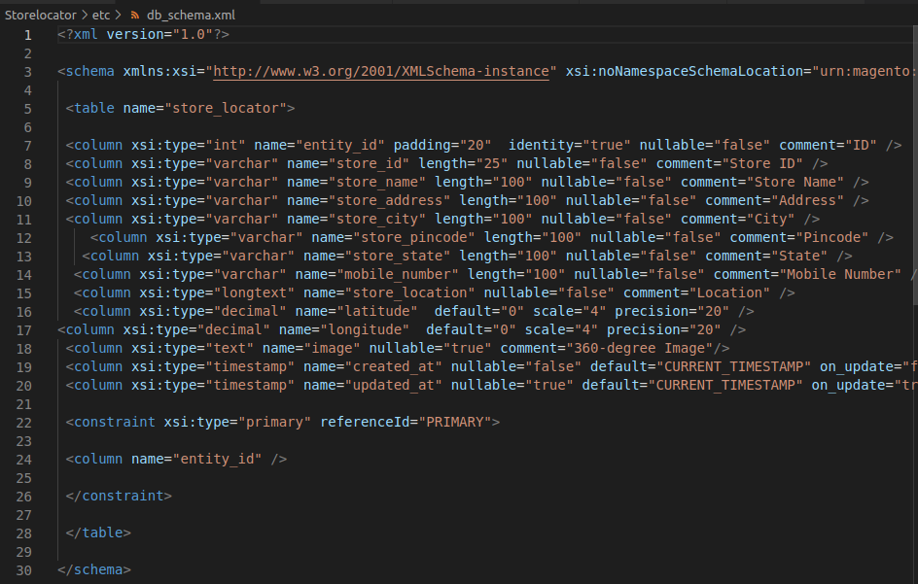

Technical Documentation

Step 4:Create the di.xml: This file configures which dependencies are injected by object manager and the application reads all the di.xml configuration files which will be merged all together by appending all nodes.

app/code/Embitel/Storelocator/etc/di.xml

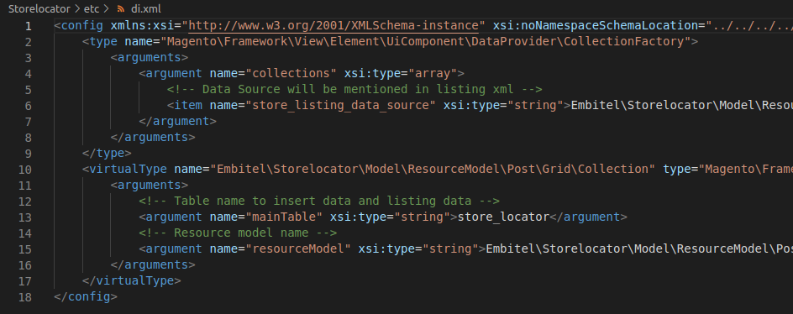
Step 5: Create the route.xml in frontend: The route will define the name for the module which will be used in the url to find the module and execute the controller action.

app/code/Embitel/Storelocator/etc/frontend/route.xml

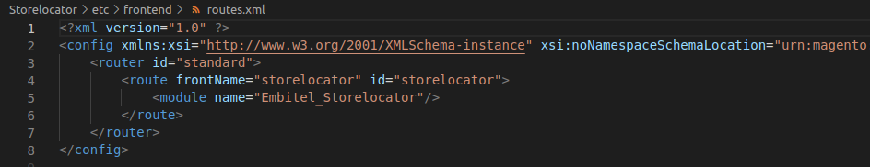
Step 6: Create the route.xml in adminhtml:
app/code/Embitel/Storelocator/etc/adminhtml/route.xml

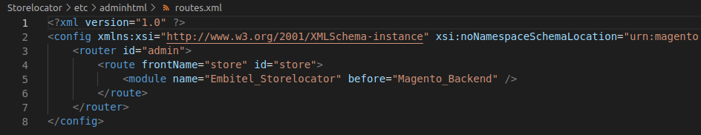

Technical Documentation

Step 7: Create the registration.php: It is used to notify to magento 2 application about the module in the system. It is also used to provide the location for register the module.

app/code/Embitel/Storelocator/registration.php

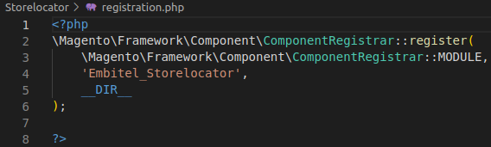

Step 8: Create the menu.xml in adminhtml: It is located in module’s etc/adminhtml folder which consists of menu nodes, config and add multiple directives.

app/code/Embitel/Storelocator/etc/adminhtml/menu.xml

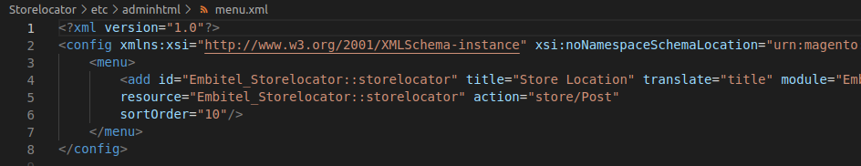
Step 9: Create the Post.php in Model: The post.php file in the model folder is a PHP class that represents the data model for a specific entity in the system. This file is typically used to define the business logic that relates to that entity, such as saving and retrieving data from the database.
app/code/Embitel/Storelocator/Model/Post.php
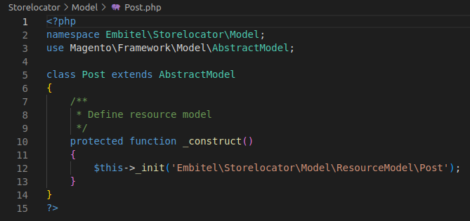

Technical Documentation

Step 10: Create the Post.php in Model-ResourceModel folder:
app/code/Embitel/Storelocator/Model/ResourceModel/Post.php
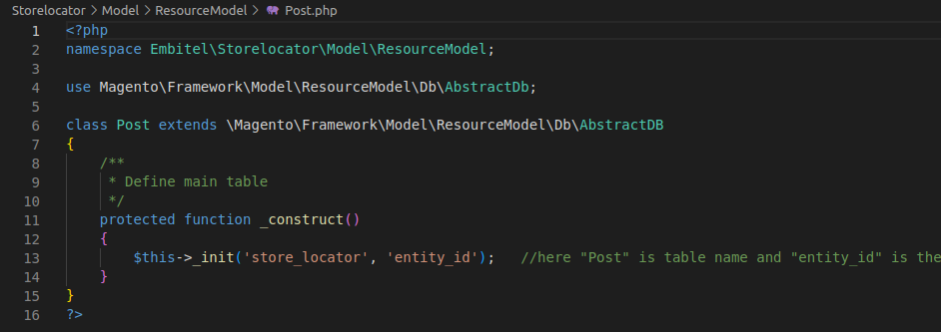
Step 11: Create the Collection.php in Model-ResouceModel-Post folder: The Collection class in Magento 2 is used to retrieve a set of data from the database. The Collection class is typically used to work with data from custom database tables or to extend core Magento 2 models and work with data from their associated database tables.
app/code/Embitel/Storelocator/Model/ResourceModel/Post/Collection.php
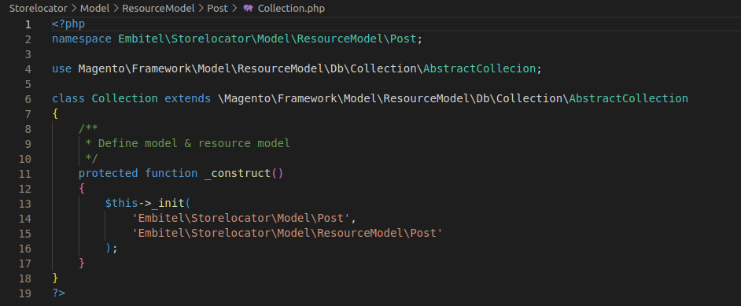

Technical Documentation

Step 12: Create the Collection.php in Model-ResouceModel-Post-Grid folder: In Magento 2, the Collection class for a grid is used to retrieve a set of data that will be displayed in the grid. The Collection class is typically defined in a file called Collection.php, which is located in the Model/ResourceModel directory of a module.
app/code/Embitel/Storelocator/Model/ResourceModel/Post/Grid/Collection.php
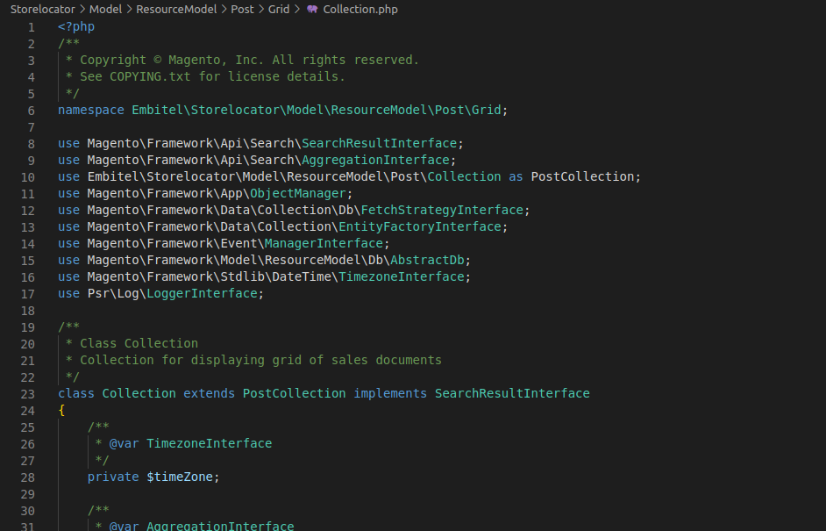
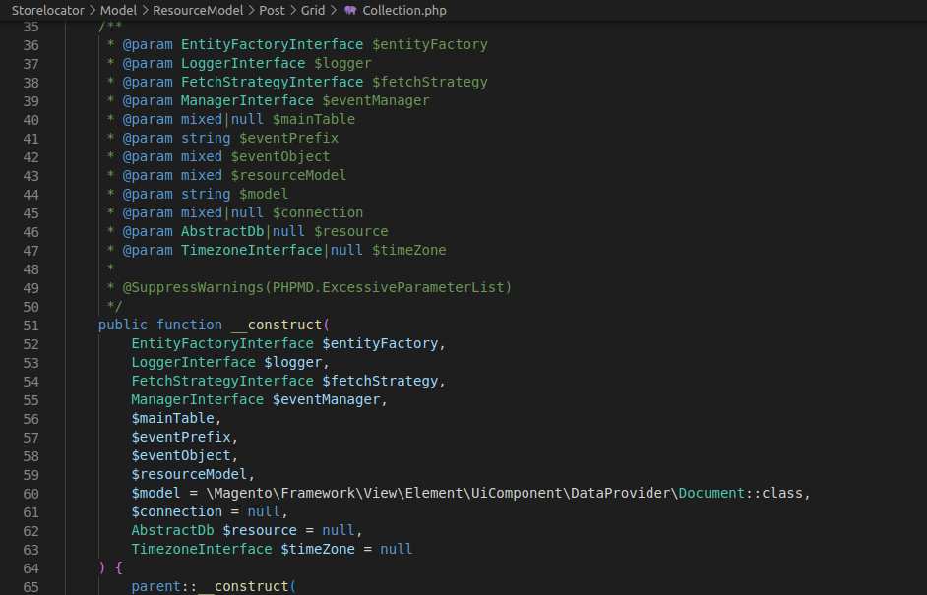
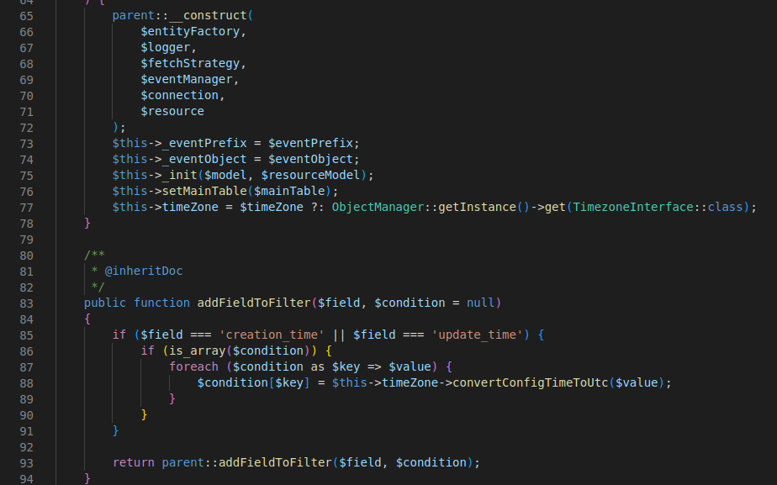
Technical Documentation

Step 13: Create the DataProvider.php: The DataProvider class for a grid is responsible for retrieving data from a collection object and preparing it for display in the grid. The DataProvider class is typically defined in a file called DataProvider.php, which is located in the model directory of a module.
app/code/Embitel/Storelocator/Model/Grid/DataProvider.php
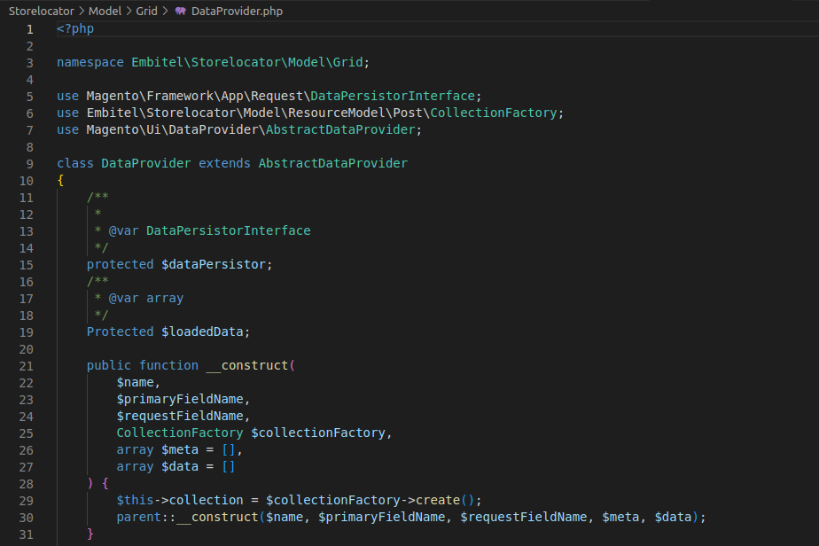
Step 14: Create the Index.php: The index.php file is located in the root directory which is the main entry point for the application. It is responsible for initializing the Magento application and routing the incoming requests to the appropriate controller.
app/code/Embitel/Storelocator/Controller/Index/Index.php
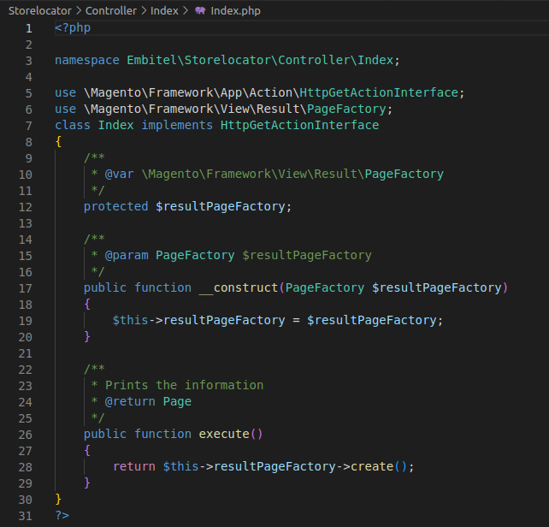

Technical Documentation

Step 15: Create the index.php in the Controller-Adminhtml:
The index.php file located in the adminhtml directory is the main entry point for the Magento admin panel. It is responsible for initializing the admin application and routing incoming requests to the appropriate controller.
app/code/Embitel/Storelocator/Controller/Adminhtml/Post/Index.php
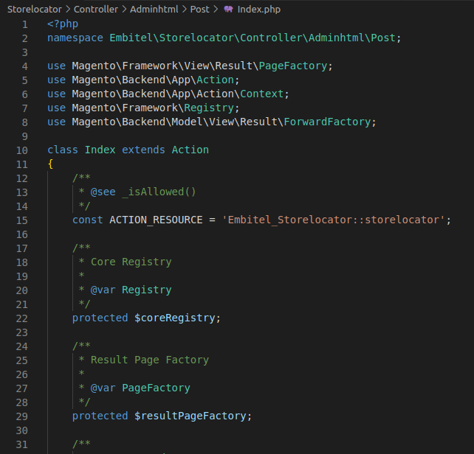
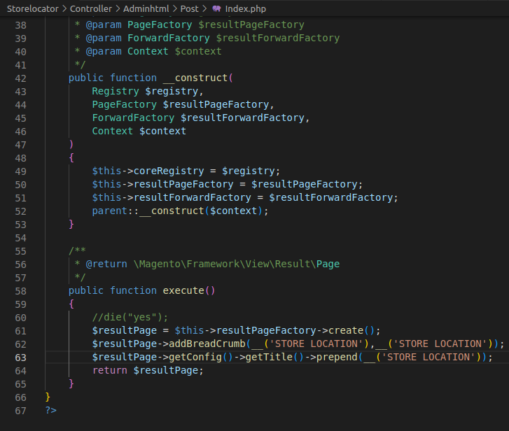

Technical Documentation

Step 16: Create the Save.php file in Controller – Adminhtml:
The save.php file in a custom controller could potentially be responsible for processing a form submission, saving data to the database, or performing some other action related to data manipulation or persistence. However, without more information about the specific context and implementation of this file, it is difficult to provide a more detailed explanation.
app/code/Embitel/Storelocator/Controller/Adminhtml/Post/Save.php
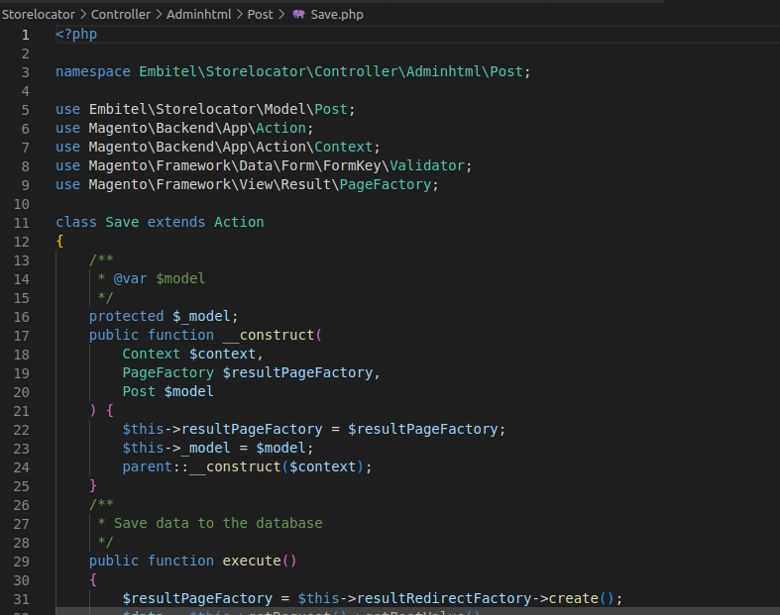
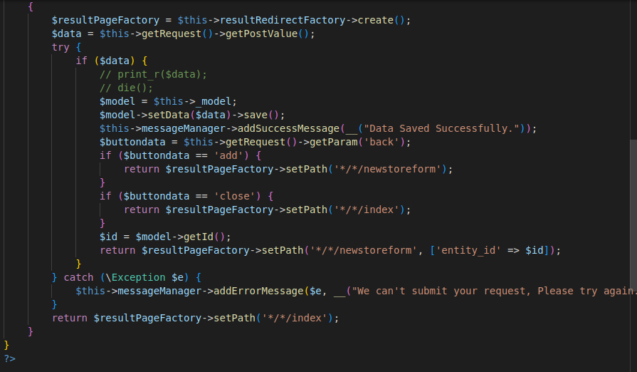

Technical Documentation

Step 17: Create the Storeform.php file in Controller folder:
A storeform.php file in a custom controller could potentially be responsible for rendering a form for creating or updating a store entity, processing a form submission, saving data to the database, or performing some other action related to store management.
app/code/Embitel/Storelocator/Controller/Adminhtml/Post/Storeform.php
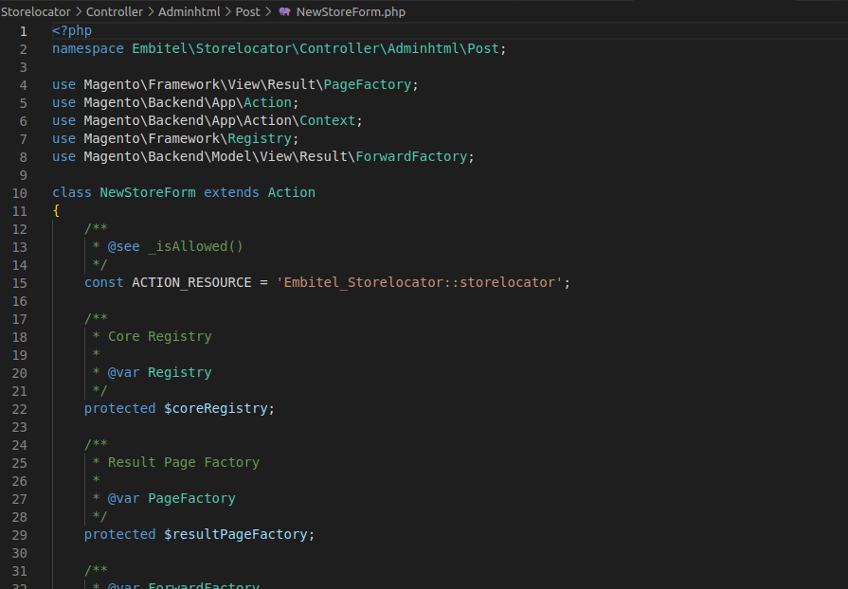
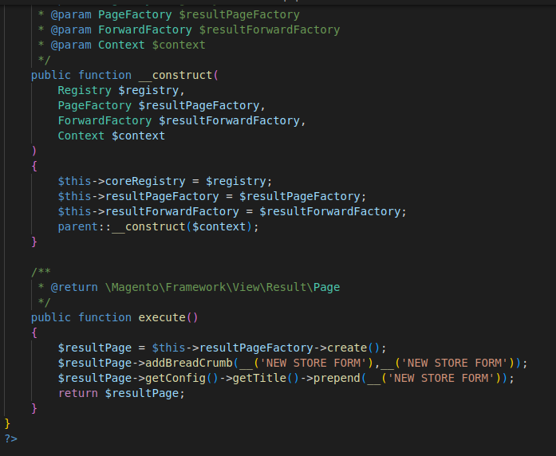
Technical Documentation

Step 18: Create the store_post_listing.xml:
Listing.xml file is a UI Component file that is used to define the structure and behavior of a listing page for a specific entity type, such as store name, address, latitude, longitude, pincode and mobile number. This file is typically located in the view/adminhtml/ui component directory of a custom module or extension and is used to configure the appearance and functionality of the listing page in the Magento Admin Panel.
app/code/Embitel/Storelocator/view/adminhtml/ui_component/store_post_listing.xml
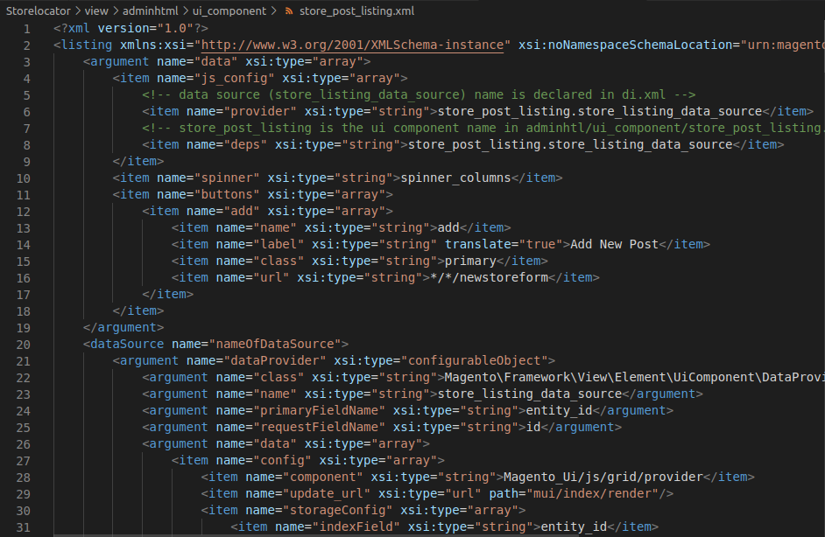

Technical Documentation

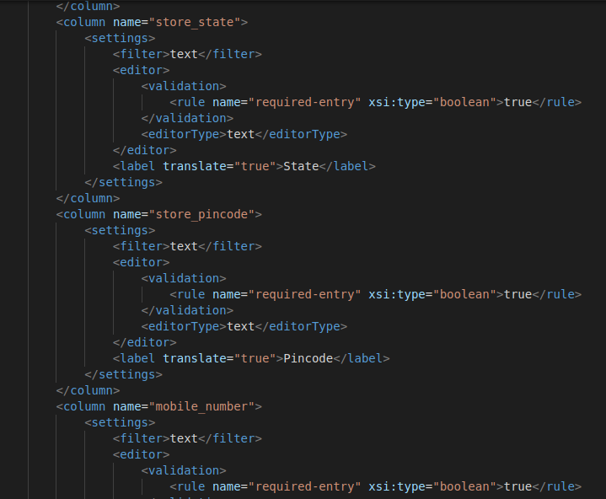
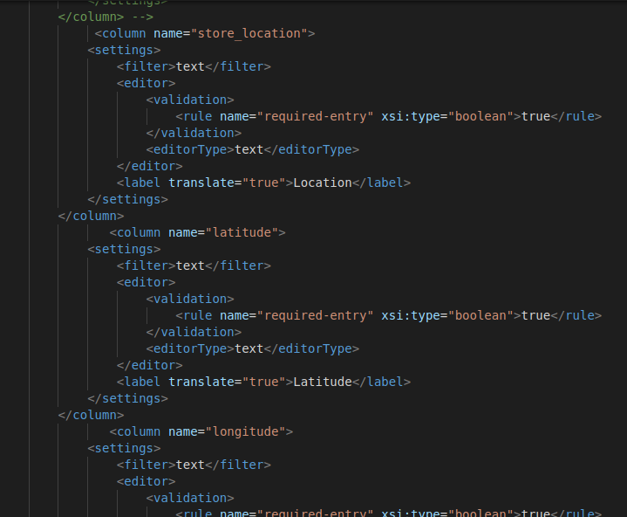

Technical Documentation
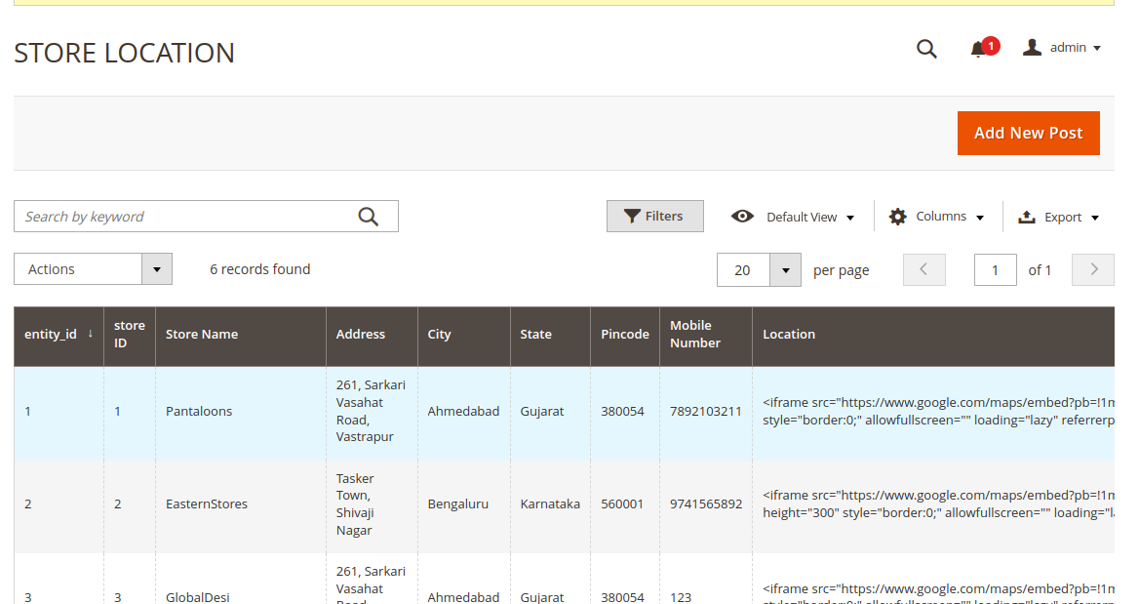

Step 18: Create the store_post_form.xml:
The form.xml file defines the structure of the form page by specifying the fields and input elements that should be displayed to the user. It also defines the data sources that should be used to populate the form fields, such as database tables or API endpoints.
app/code/Embitel/Storelocator/view/adminhtml/ui_component/store_post_form.xml
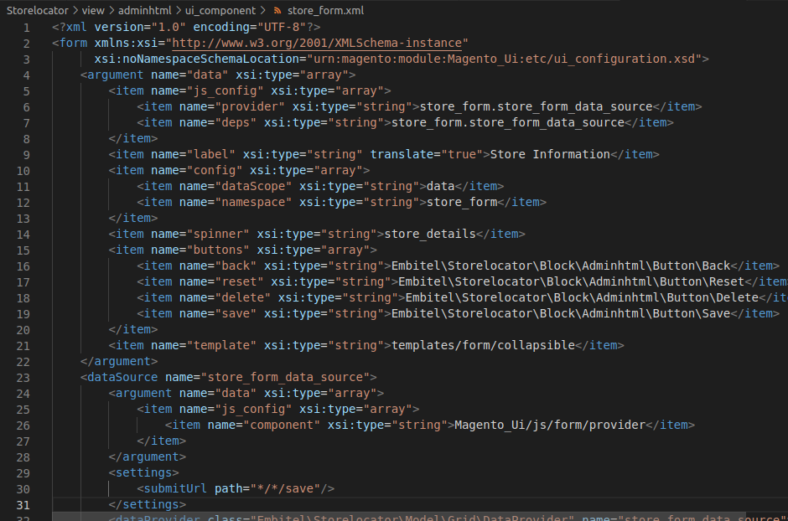
Technical Documentation
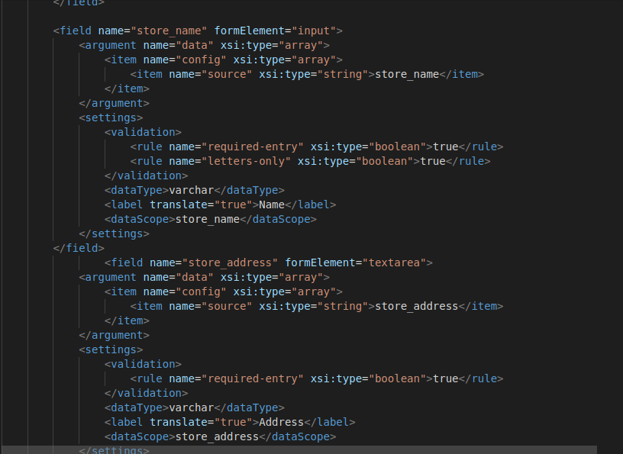
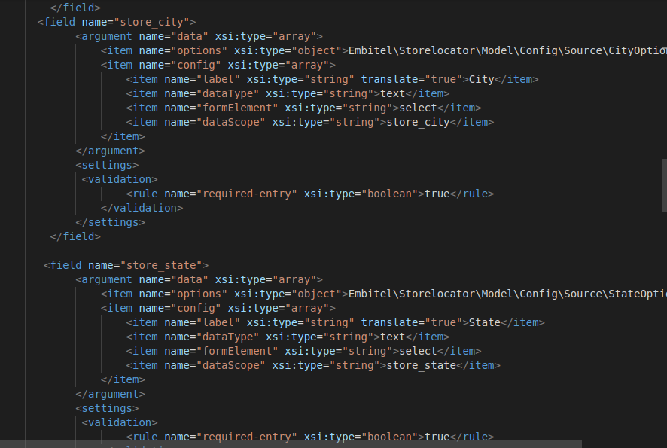

Technical Documentation
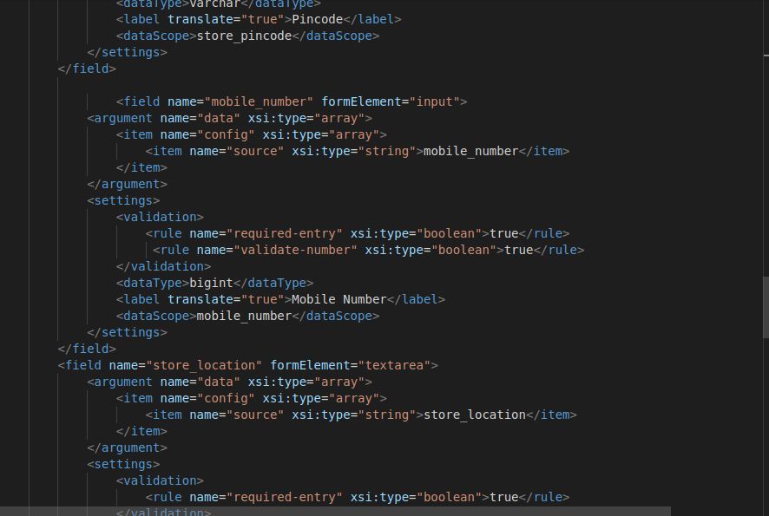
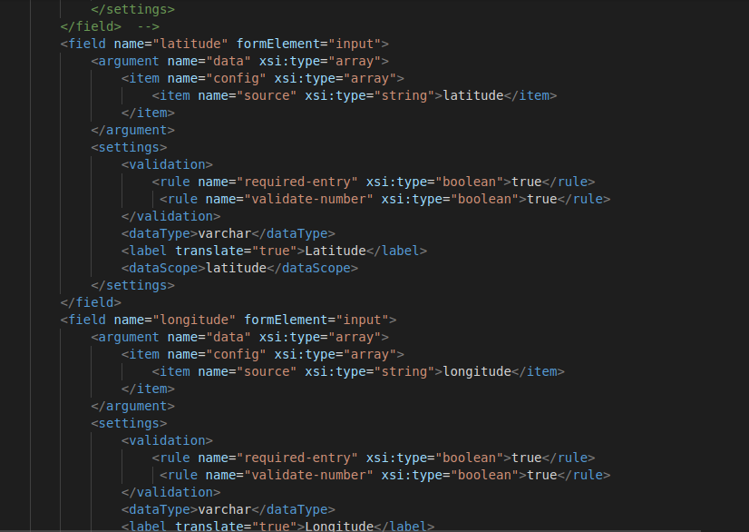
Technical Documentation

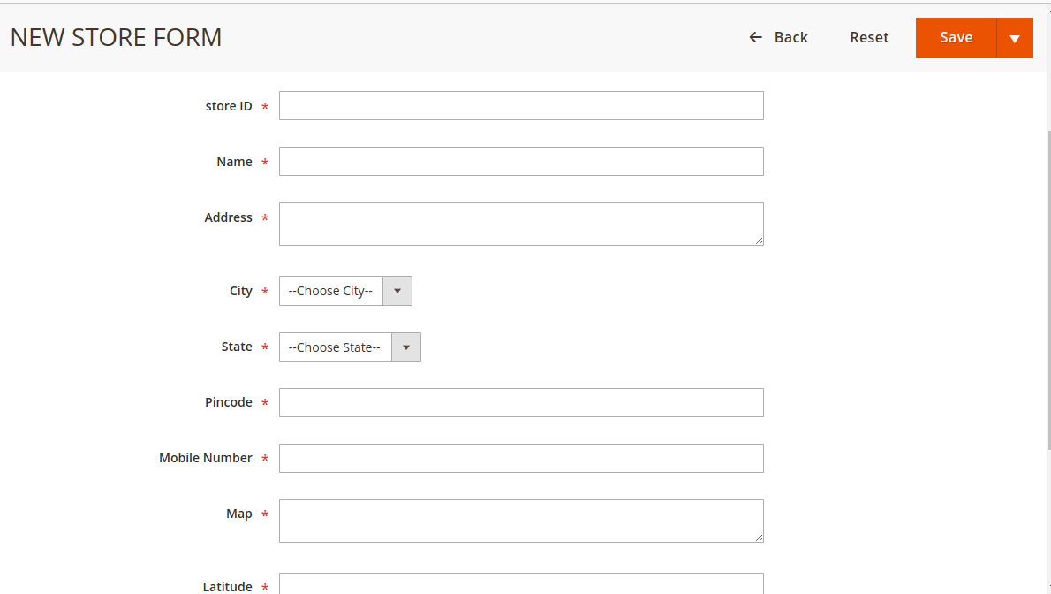

Step 19: Create the store_post_index.xml in view-adminhtml-layout folder:
The index.xml file can define the layout of the blocks on the dashboard page, such as the position, size, and alignment of each block. It can also specify the content that should be displayed in each block, such as store name, store address, mobile number, latitude, longitude, map and pincode.
app/code/Embitel/Storelocator/view/adminhtml/layout/store_post_index.xml

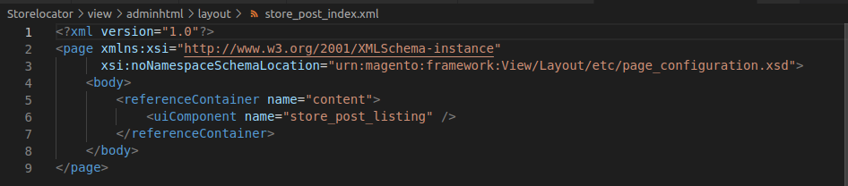

Technical Documentation

Step 20: Create the store_post_form.xml in view-adminhtml-layout folder:
The form.xml file can define the layout of the blocks on the dashboard page, such as the position, size, and alignment of each block. It can also specify the content that should be displayed in each block, such as store name, store address, mobile number, latitude, longitude, map and pincode.
The form.xml file include instructions for adding custom buttons or actions to the form page, or for modifying existing buttons or actions to add additional functionality or styling.
app/code/Embitel/Storelocator/view/adminhtml/layout/store_post_form.xml
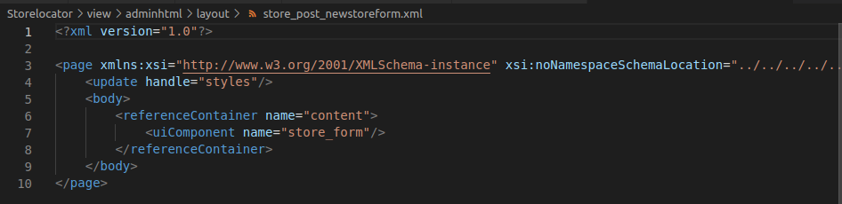
2.2 ADDING THE BUTTONS:
1. Back.php: In Magento the back button is used to navigate to the previous page in the users browsing history.
app/code/Embitel/Storelocator/Block/Adminhtml/Buttons/Back.php
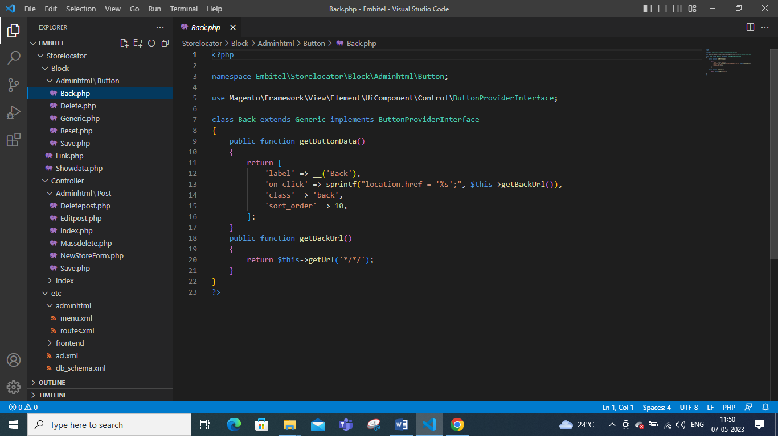

Technical Documentation

2. Delete.php: The delete button is used to delete the details of the storelocator in which the user can add the other details in the store form.
app/code/Embitel/Storelocator/Block/Adminhtml/Buttons/Delete.php
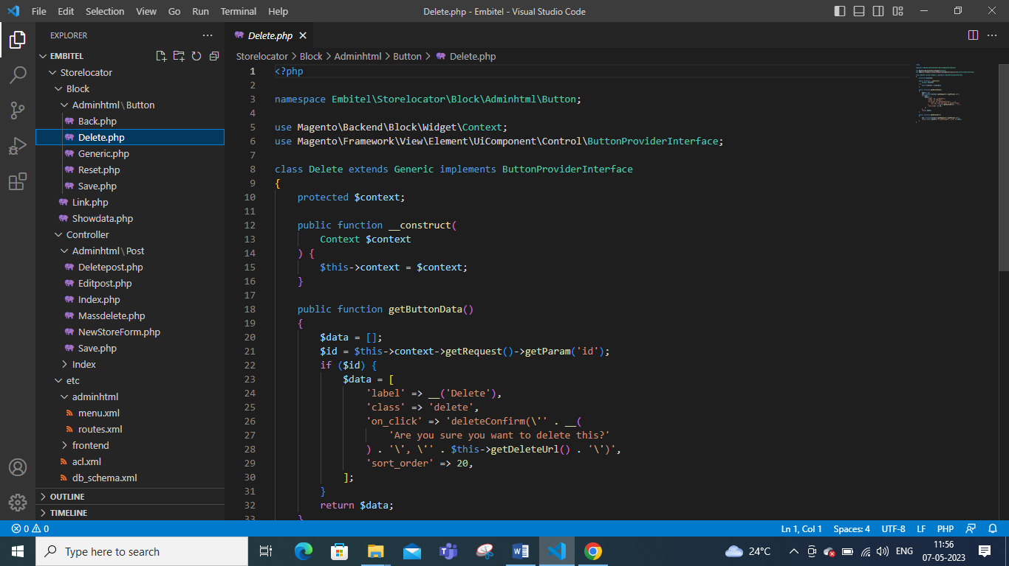
3.Generic.php: app/code/Embitel/Storelocator/Block/Adminhtml/Buttons/Generic.php
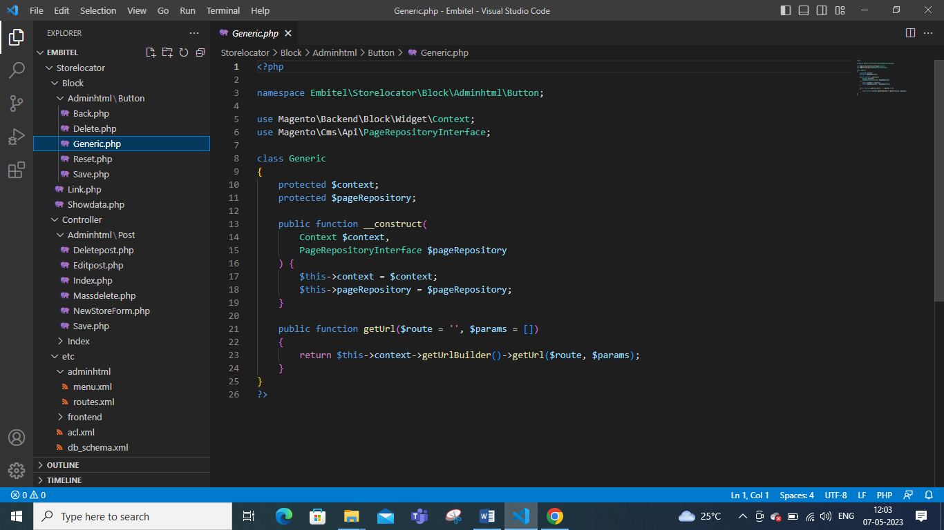

Technical Documentation

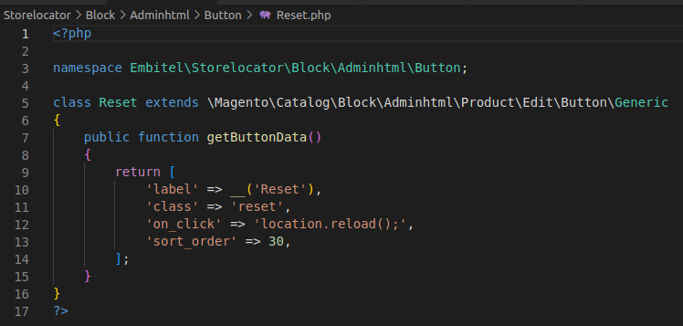
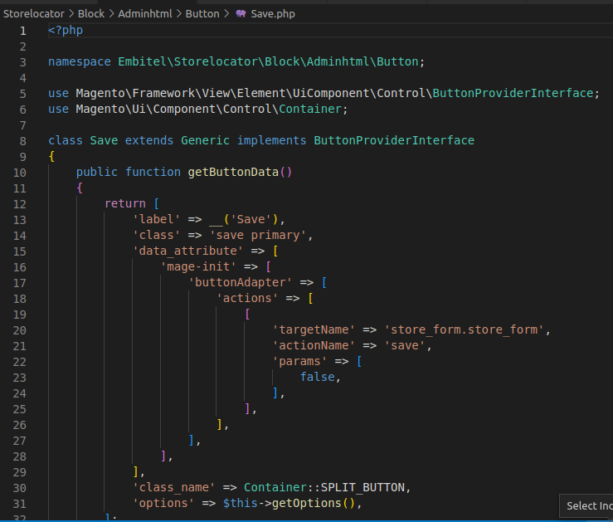
4. Reset.php: It is typically used to undo any changes made to the form or configuration settings and restore the default values and found in the same page of save button in which the user can change various settings related to the stores.
app/code/Embitel/Storelocator/Block/Adminhtml/Buttons/Reset.php

5. Save.php: The save.php is used to apply the changes made to a form or configuration changes and update the corresponding entity in the system and the user can make changes in the store form such as store name, address, mobile number, pincode, city and state.
app/code/Embitel/Storelocator/Block/Adminhtml/Buttons/Save.php

Technical Documentation

2.3 ADDING UI COMPONENT:
1. Delete.php: It is the standard file name used in the adminhtml controller directory to handle the deletions of specific entity in which the customer can delete the details of the storelocation information.
app/code/Embitel/Storelocator/Controller/Adminhtml/Post/Delete.php
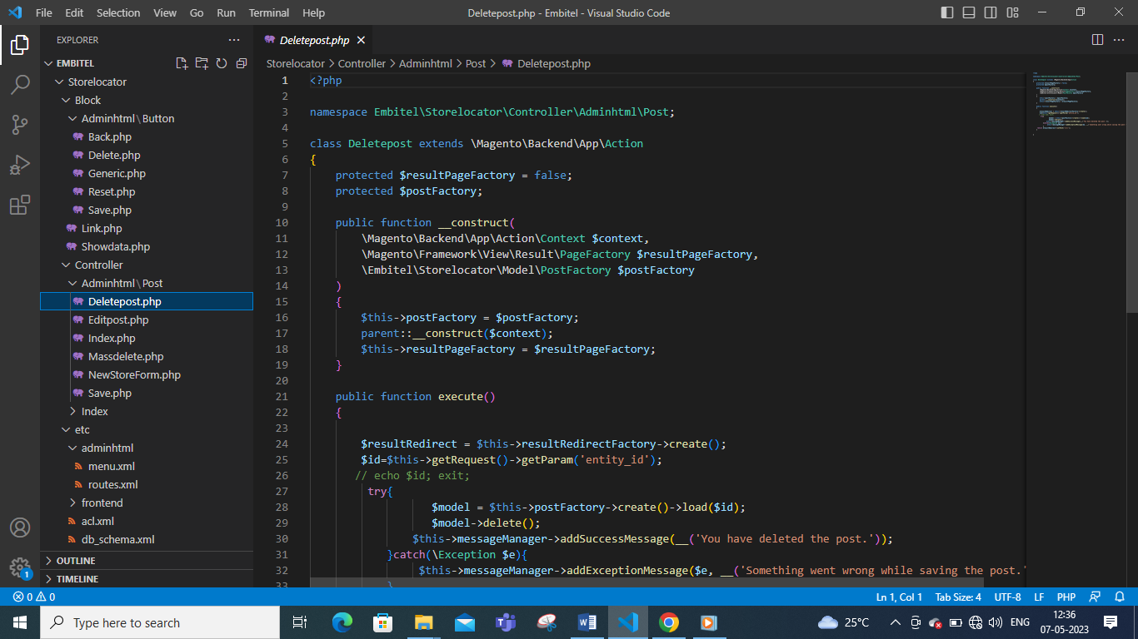

2. Edit.php: It is the standard file name used in the adminhtml controller directory to handle the deletions of specific entity in which the customer can edit the details of the storelocation information.
app/code/Embitel/Storelocator/Controller/Adminhtml/Post/Edit.php
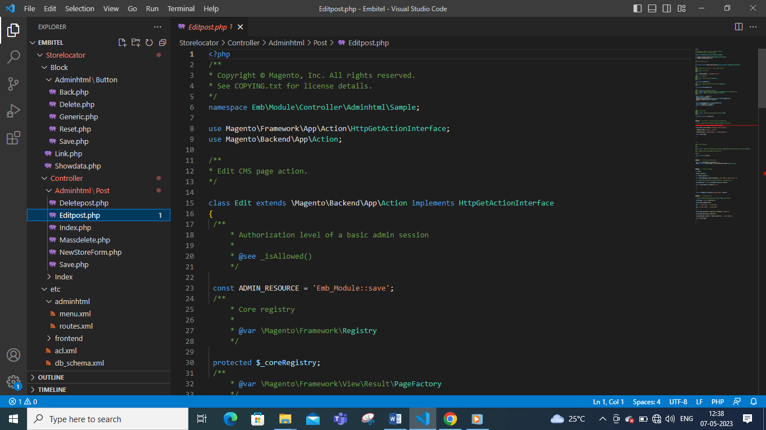

Technical Documentation
2.4 UI COMPONENT:
1. Action.php: It is a file in the UI component directory that is responsible for handling various actions triggered by the user interface. This file receives the request from UI components and execute the corresponding action based on the request parameter.
app/code/Embitel/Storelocator/Ui/Component/Listing/Blog/Column/Action.php
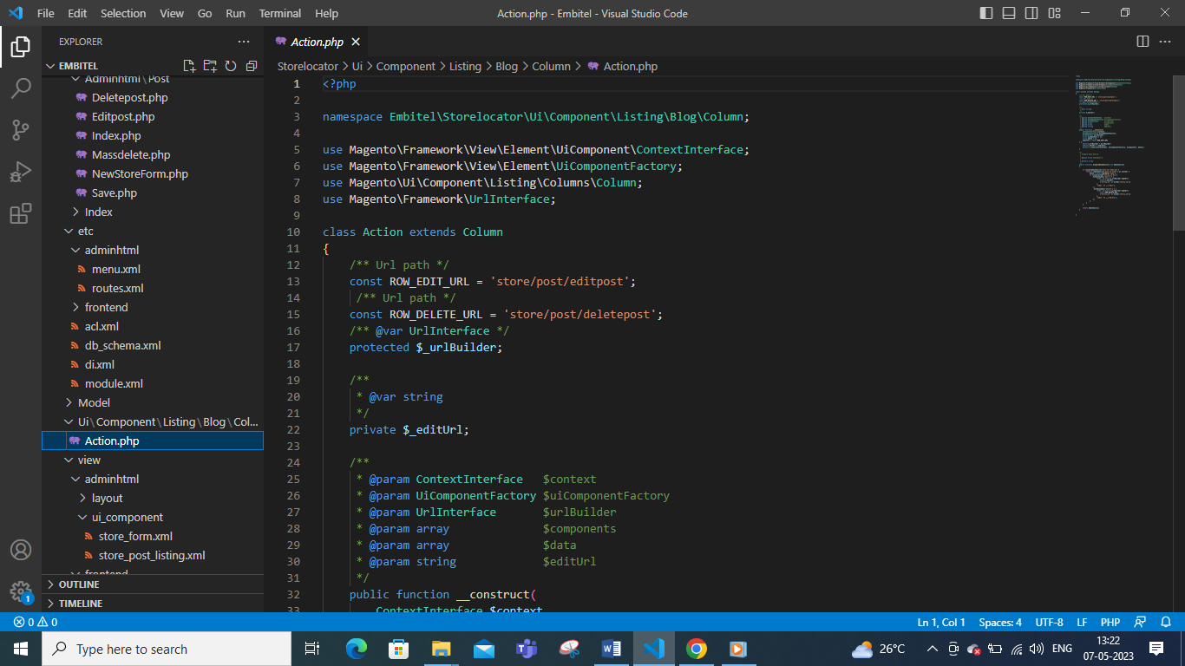
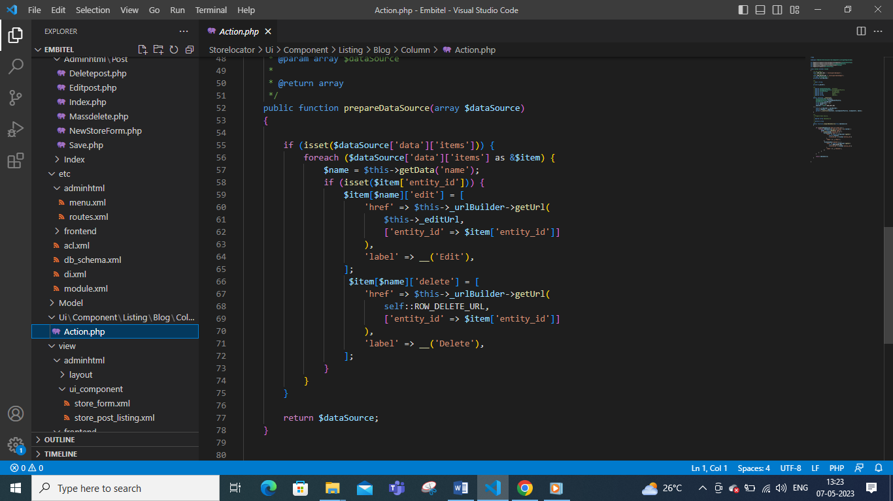

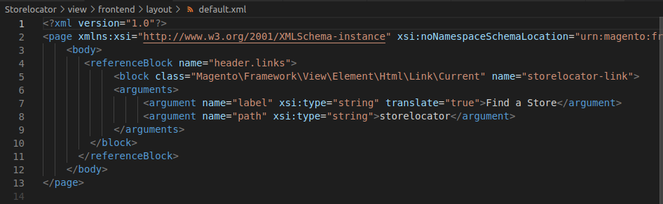
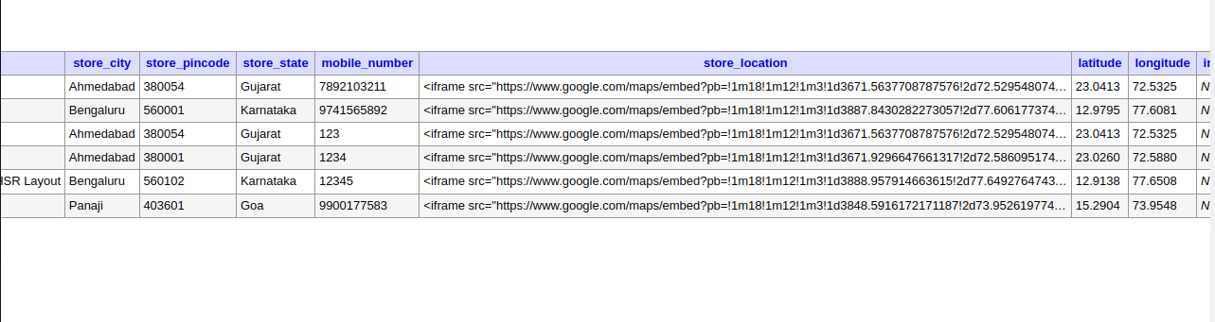
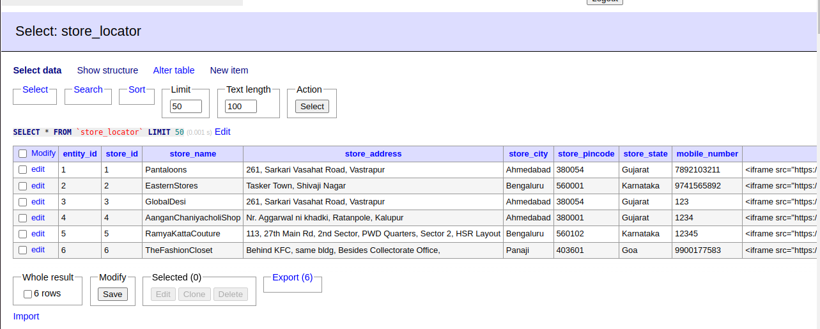
Technical Documentation
2.5 Creating the Database:
The data stored in the database is typically MySQL databe in which the datas can be stored such as store id, store name, store address, mobile number, pincode, latitude, longitude and google map in the adminer.php.

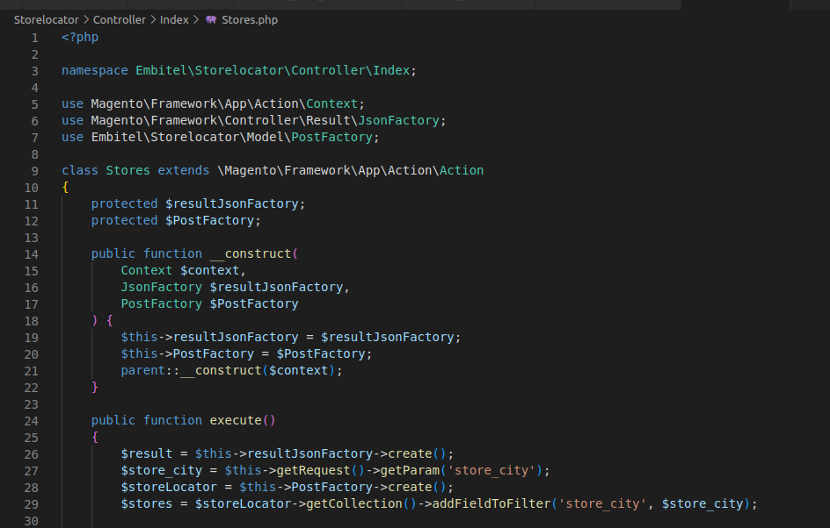
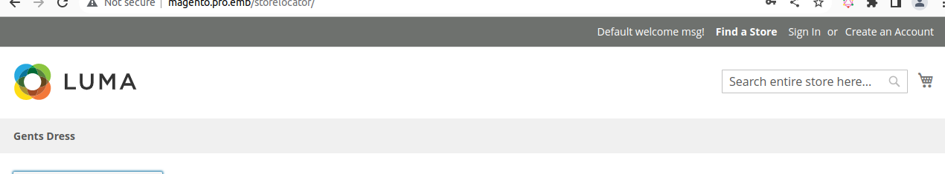

2.6 Creating the Header Tag in Magento Home Page:
Step 1: Create the default.xml file:
It is the XML file that controls the layout and presentation of the Magento admin area’s frontend. It is responsible for setting up the default layout and adding various blocks and elements to the page.
app/code/Embitel/Storelocator/view/adminhtml/frontend/layout/default.xml

Technical Documentation

2.7 Creating the Dropdown menu:
In Magento, the dropdown menu for selecting a city is typically used in the checkout process or in customer account forms where users need to specify the cities to select their stores.
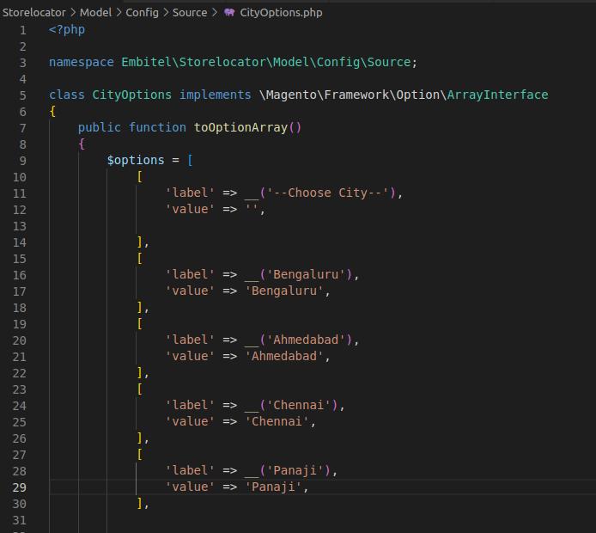
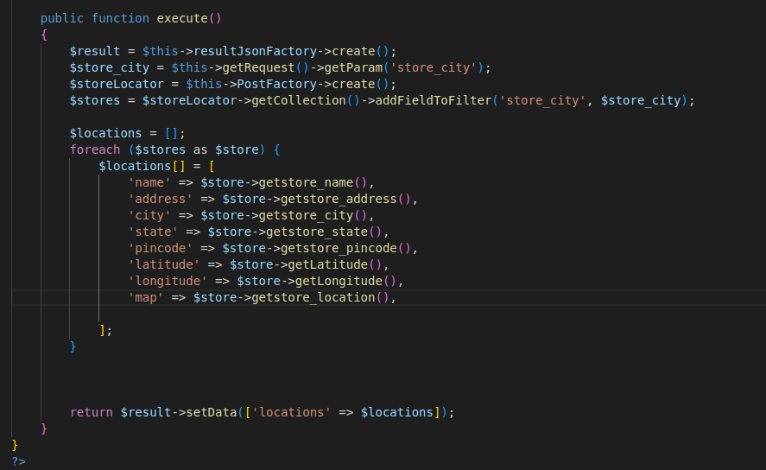
The dropdown menu is usually populated dynamically based on the country and state/province selected by the user. When a user selects a country or state, a JavaScript function is triggered that sends an AJAX request to the server to fetch the list of cities for the selected country and state.
Step1: Create the Store.php in the Controller-Adminhtml-Index folder
app/code/Embitel/Storelocator/Controller/Adminhtml/Index/Store.php

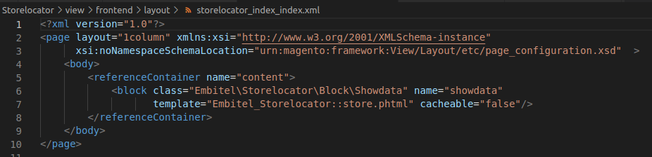
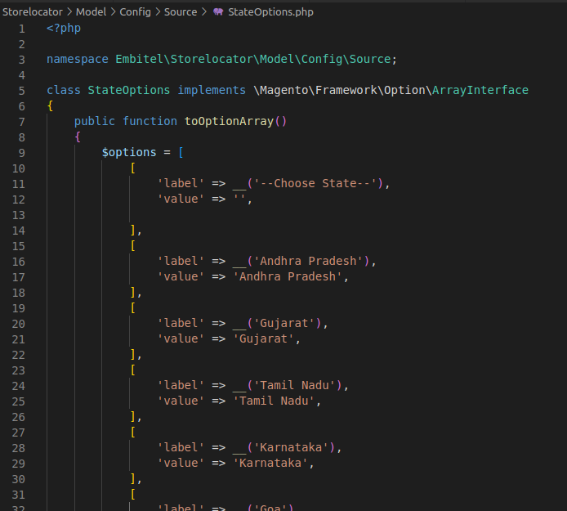
Technical Documentation

Step 2: Create the CityOptions.php
app/code/Embitel/Storelocator/Model/Config/Source/CityOptions.php

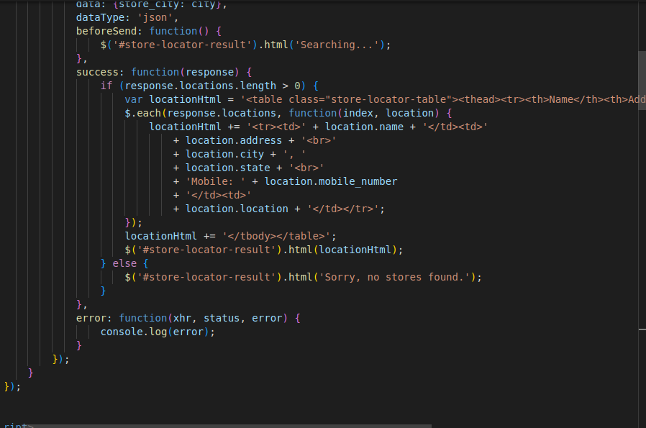
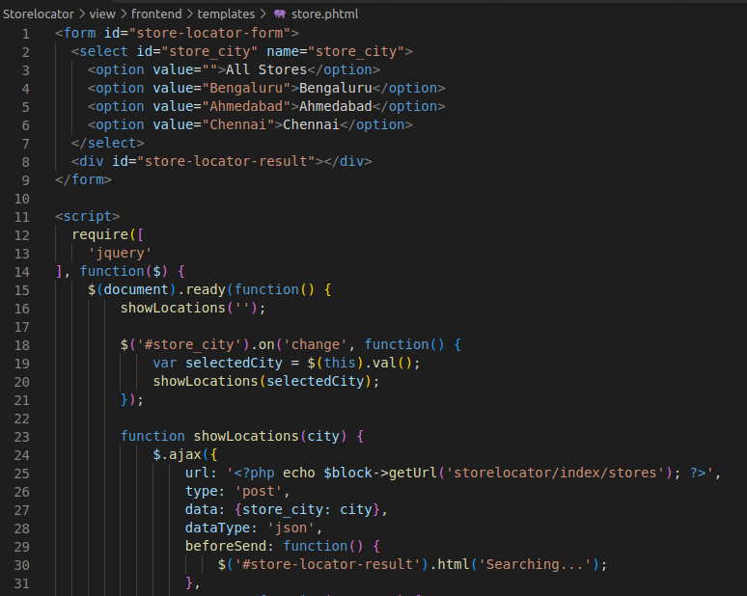

Technical Documentation

Step 3: Create the StateOptions.php
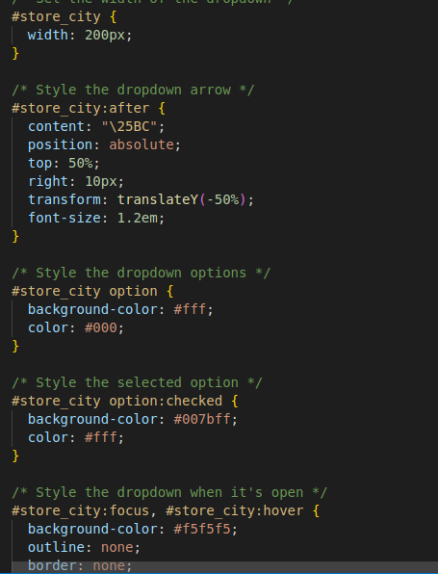
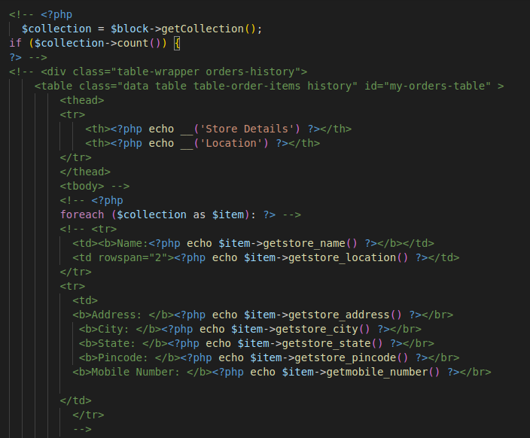
app/code/Embitel/Storelocator/Model/Config/Source/StateOptions.php

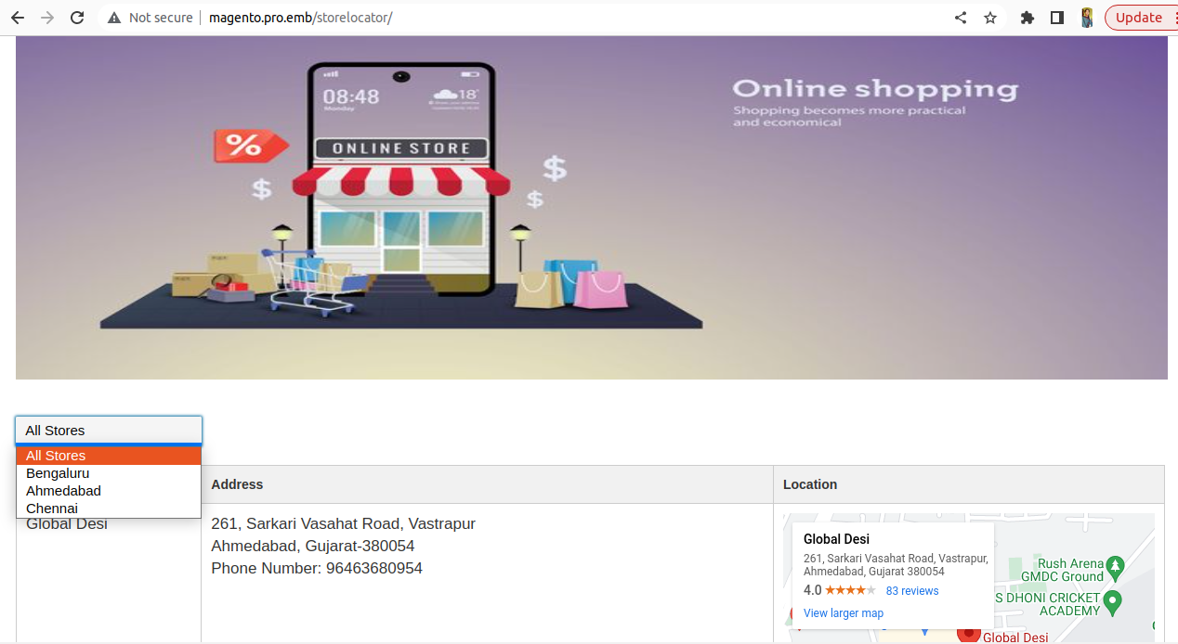
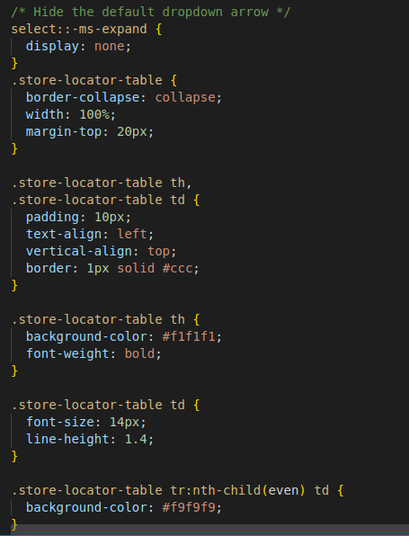
Step 4: Create the Storelocator_index_index.xml
app/code/Embitel/Storelocator/view/frontend/layout/storelocator_index_index.xml

Technical Documentation

Step 5: Create the Store.phtml
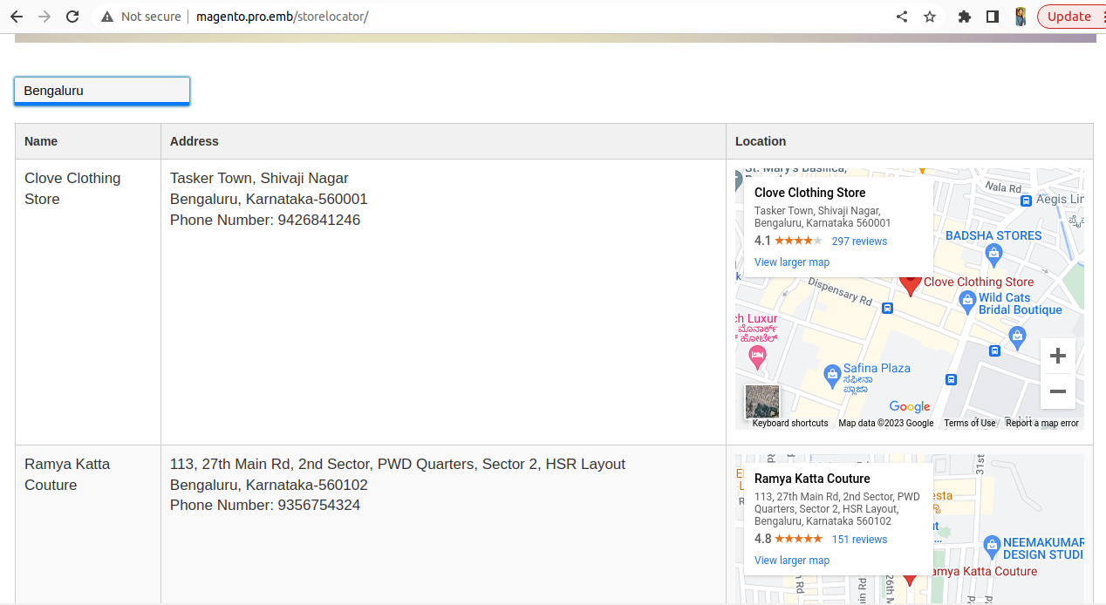
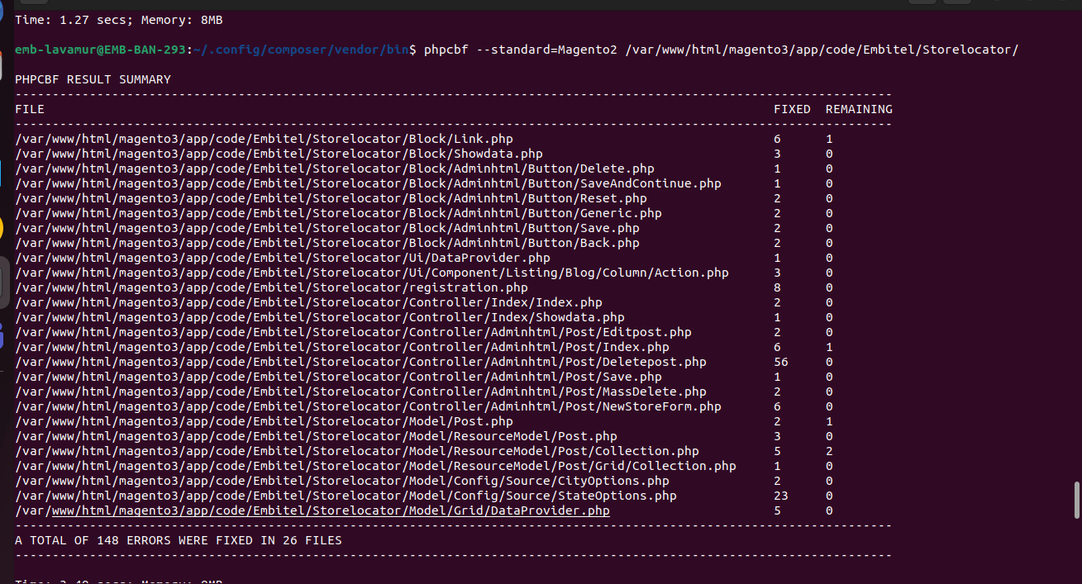
app/code/Embitel/Storelocator/view/frontend/templates/store.phtml

Technical Documentation

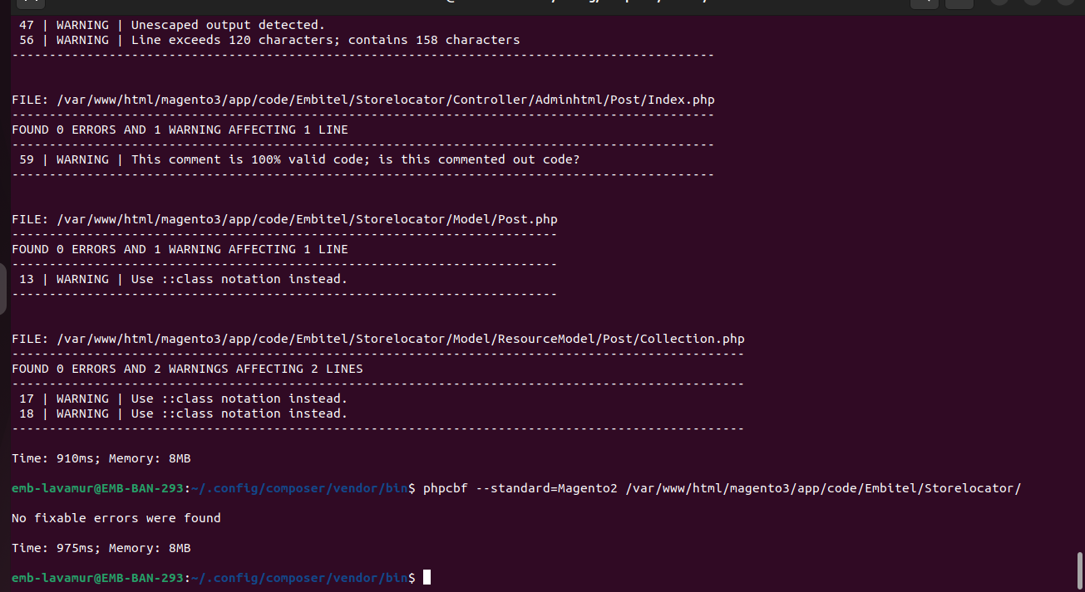

Technical Documentation

Technical Documentation

3. CODESNIFFER:
It is the static test that uses static code analysis to detect the violations of Magento Coding Standards to prevent common coding errors.

Technical Documentation

